**Project Design Phase-II**

**Data Flow Diagram & User Stories**

|  |  |
| --- | --- |
| Date | 13 October 2022 |
| Team ID | PNT2022TMID40747 |
| Project Name | Project – Web phishing Detection |
| Maximum Marks | 4 Marks |

**Data Flow Diagrams:**

A Data Flow Diagram (DFD) is a traditional visual representation of the information flows within a system. A neat and clear DFD can depict the right amount of the system requirement graphically. It shows how data enters and leaves the system, what changes the information, and where data is stored.

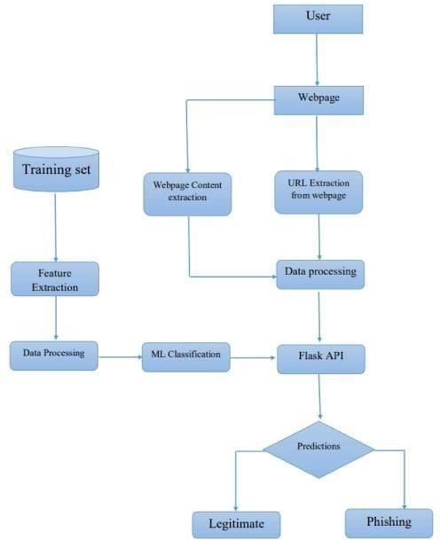

**User Stories**

Use the below template to list all the user stories for the product.

|  |  |  |  |  |  |  |
| --- | --- | --- | --- | --- | --- | --- |
| **User Type** | **Functional**  **Requirement**  **(Epic)** | **User Story Number** | **User Story / Task** | **Acceptance criteria** | **Priority** | **Release** |
| Customer  (Mobile user) | Registration | USN-1 | As a user, I can register for the application by entering my email, password, and confirmingmy password. | I can access my account / dashboard | High | Sprint-1 |
|  |  | USN-2 | As a user, I will receive confirmation email once I have registered for the application | I can receive confirmation email & click confirm | High | Sprint-1 |
|  |  | USN-3 | As a user, I can register for the application through Facebook | I can register & access the dashboard with Facebook  Login | Low | Sprint-2 |
|  |  | USN-4 | As a user, I can register for the application through Gmail |  | Medium | Sprint-1 |
|  | Login | USN-5 | As a user, I can log into the application by entering email & password |  | High | Sprint-1 |
|  | Dashboard |  |  |  |  |  |
| Customer (Web user) | User input | USN-1 | As a user i can input the particular URL in the required field and waiting for validation. | I can go access the website without any problem | High | Sprint-1 |
| Customer Care Executive | Feature extraction | USN-1 | After i compare in case if none found on comparison then we can extract feature using heuristic and visual similarity approach. | As a User i can have comparison between websites for security. | High | Sprint-1 |
| Administrator | Prediction | USN-1 | Here the Model will predict the URL websites using  Machine Learning algorithms such as Logistic Regression, KNN | In this i can have correct prediction on the particular algorithms | High | Sprint-1 |
|  | Classifier | USN-2 | Here i will send all the model output to classifier in order to produce final result. | I this i will find the correct classifier for producing the result | Medium | Sprint-2 |